Dividing Whole Numbers

Lesson 1

1. 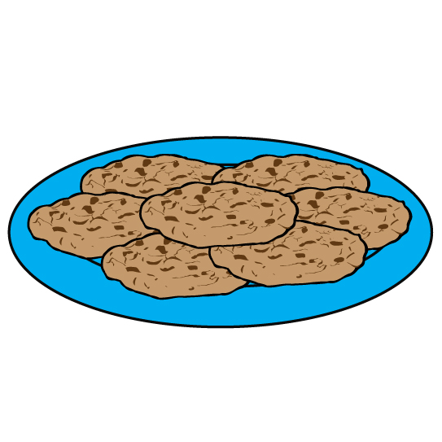Ben’s mom bought four packages of cookies when she went to the store. There is a total of 48 cookies in all four packages. If Ben eats six cookies each week, how many weeks will the cookies last?

__________________ cookies total __________________ cookies per week

­­­­_____________________ weeks

$×$ ­­­­________________ ________________ =

$÷$ ________________

________________ ________________ = ________________

**Array**

1. 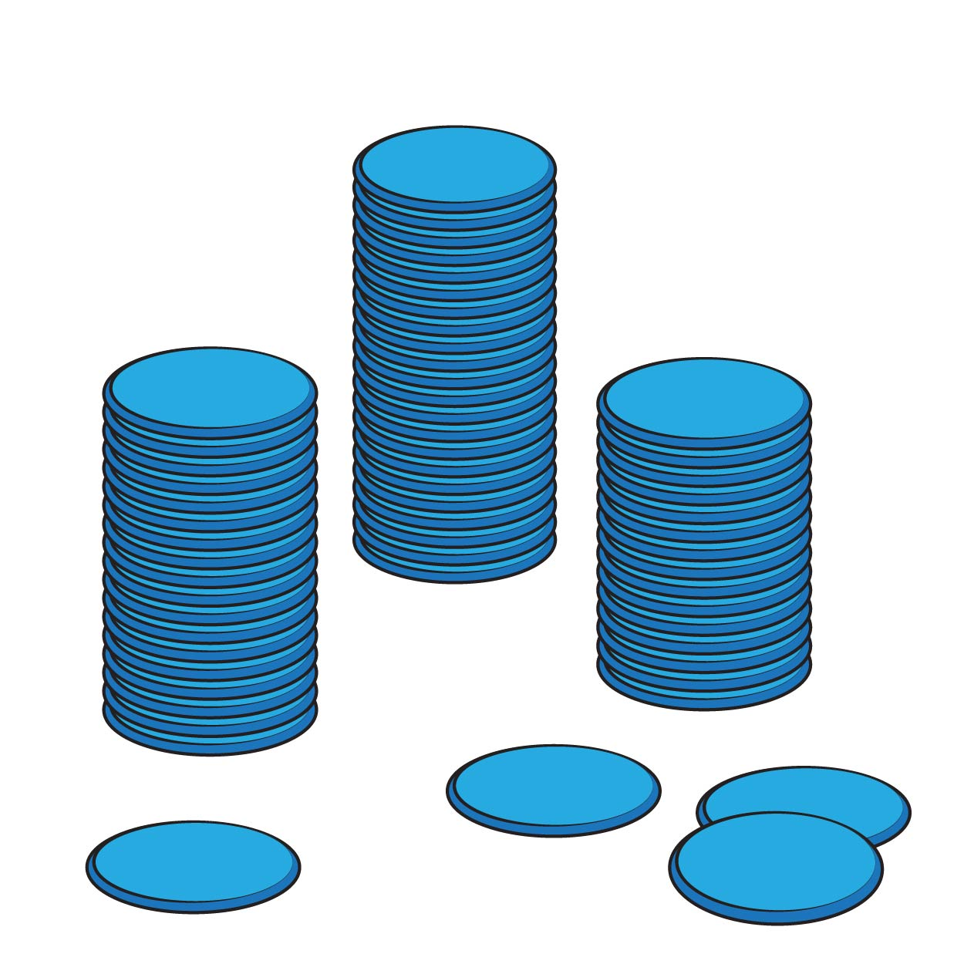Ms. Baxter was working with six students at her round table. To complete a math problem, Ms. Baxter gave each student a group of counters. She had a total of 84 counters at her round table. How many counters did each student get?

6 $×$________________ = 84

84 $÷$ 6 = ________________

­­­­The number in the blanks represents:

**Array**

1. Jules and Brett were having a Fourth of July party. They invited 11 of their friends to eat hamburgers and hotdogs. For dessert, everyone received a bag of red, white, and blue candy. If Jules bought 91 pieces of candy, how many pieces will each person get? Be sure to include Jules and Brett.

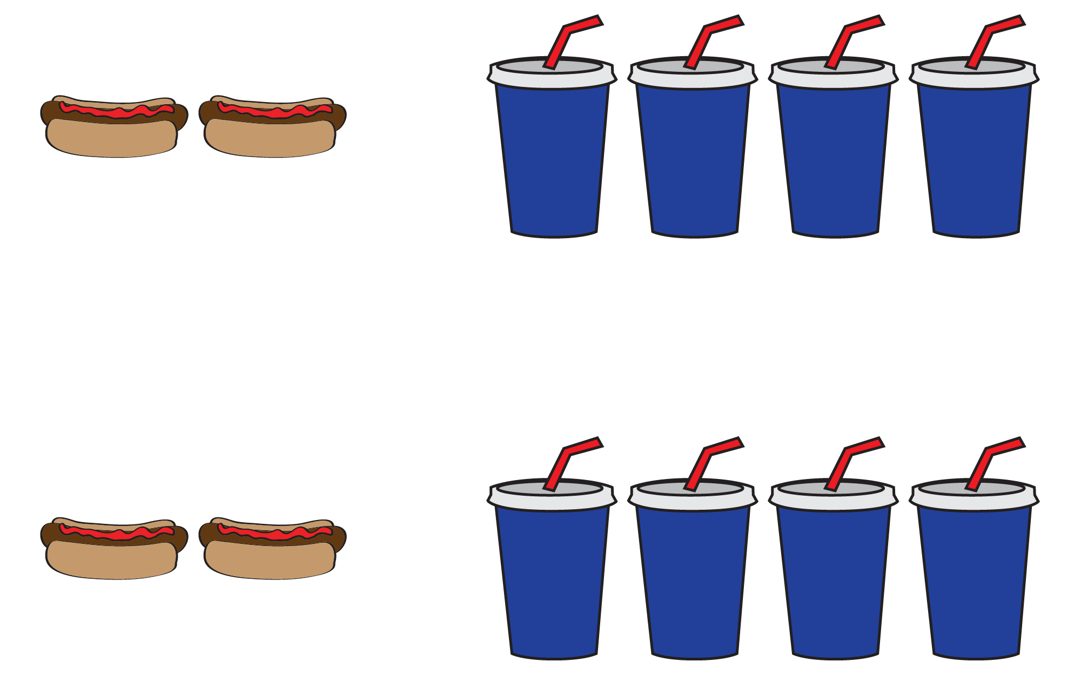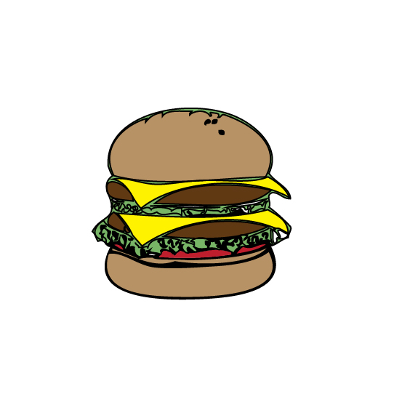

13 $×$________________ = 91 91 $÷$ 13 = ________________

­­­­The number in the blanks represents:

The 13 represents:

**Array**

1. 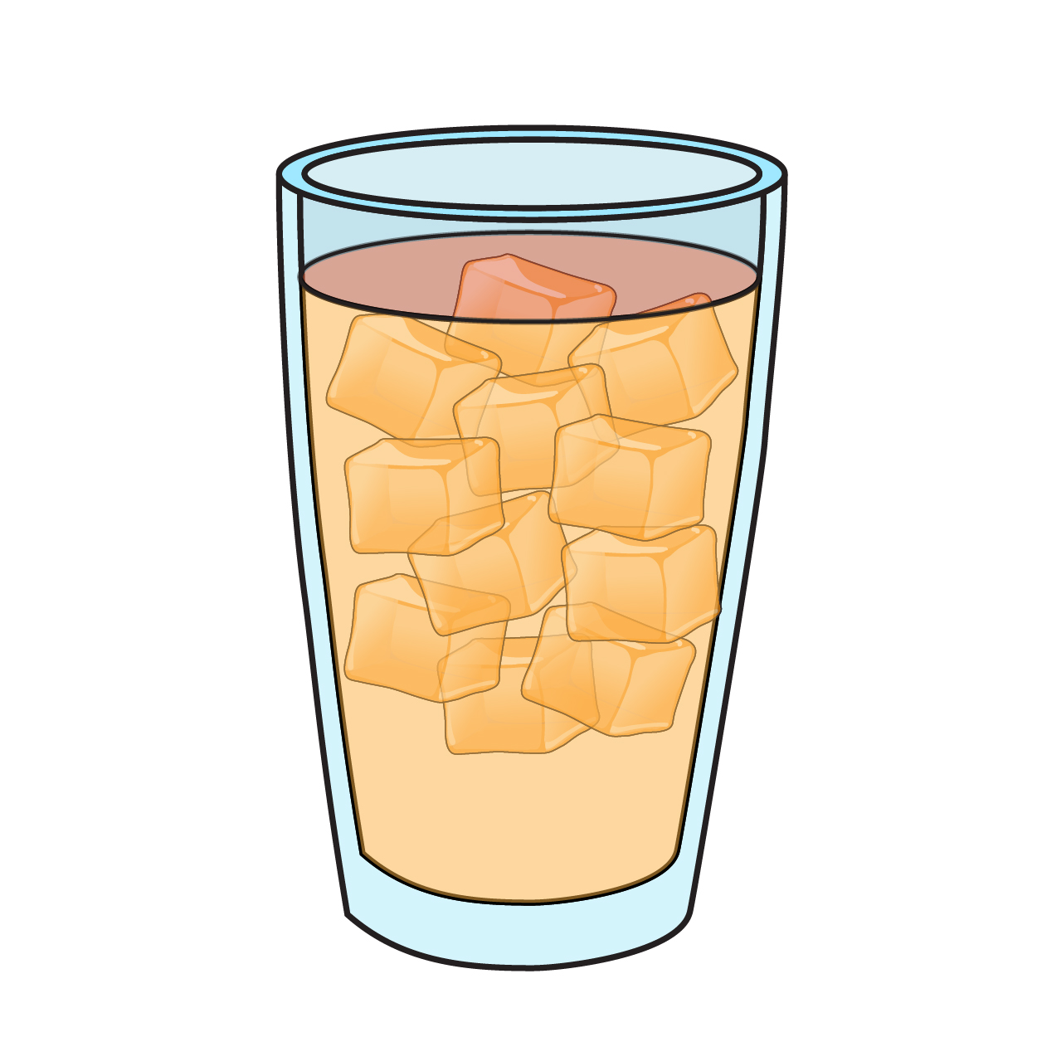Daniel enjoys drinking one iced tea during his lunch. The tea from the vending machine costs $2. Daniel budgeted to spend $46 on iced teas from the vending machine. How many days can Daniel buy one iced tea for lunch? Use the number line to complete the following blanks.

$×$________________ ________________ = 46

46 $÷$________________ = ________________

­­­­The number 46 represents:

The number ________________ represents:

The number ________________ represents:

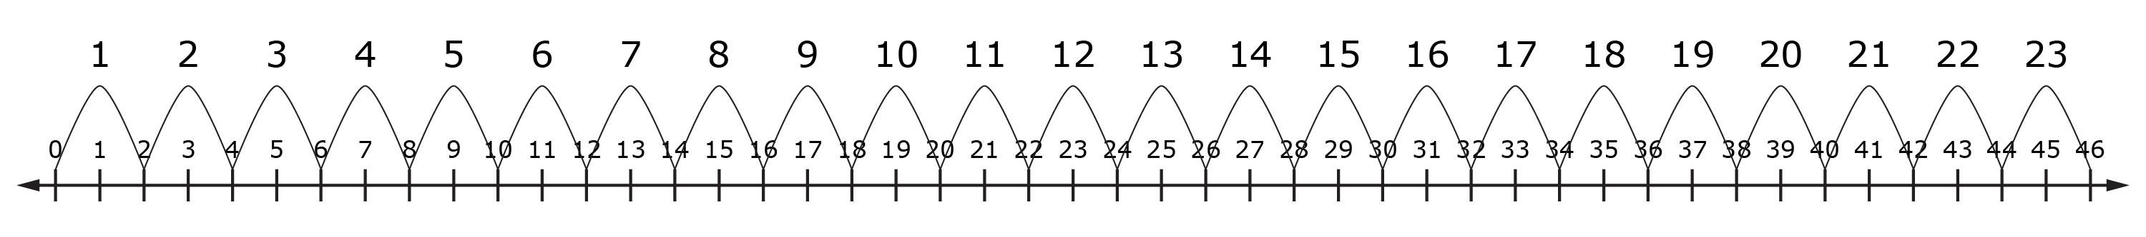

1. Madison was cleaning her bathroom and she found 57 hair ties. She placed them in groups based on their color. When she was finished, she had groups of 19 hair ties. How many different colors did Madison have?

$×$________________ ________________ =

$÷$ ________________

________________ ________________ = ________________

­­­­

The number ________________ represents:

The number ________________ represents:

The number ________________ represents:

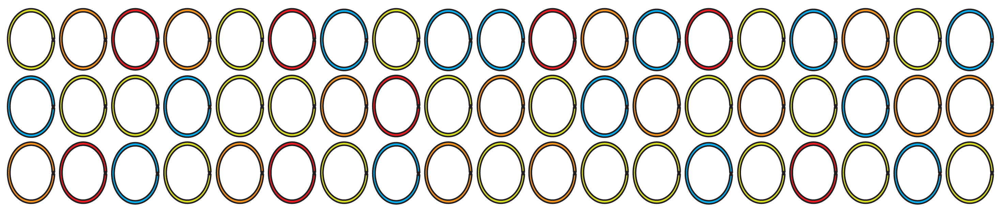

**Array**

1. Use the array to complete the blanks. Then, create a problem situation for the division equation.

$×$________________ ________________ =

$÷$ ________________

________________ ________________ = ________________

­­­­The number ________________ represents:

The number ________________ represents:

The number ________________ represents:

**Problem Situation**

**Array**



1. Explain the difference between the two arrays in terms of a division equation.

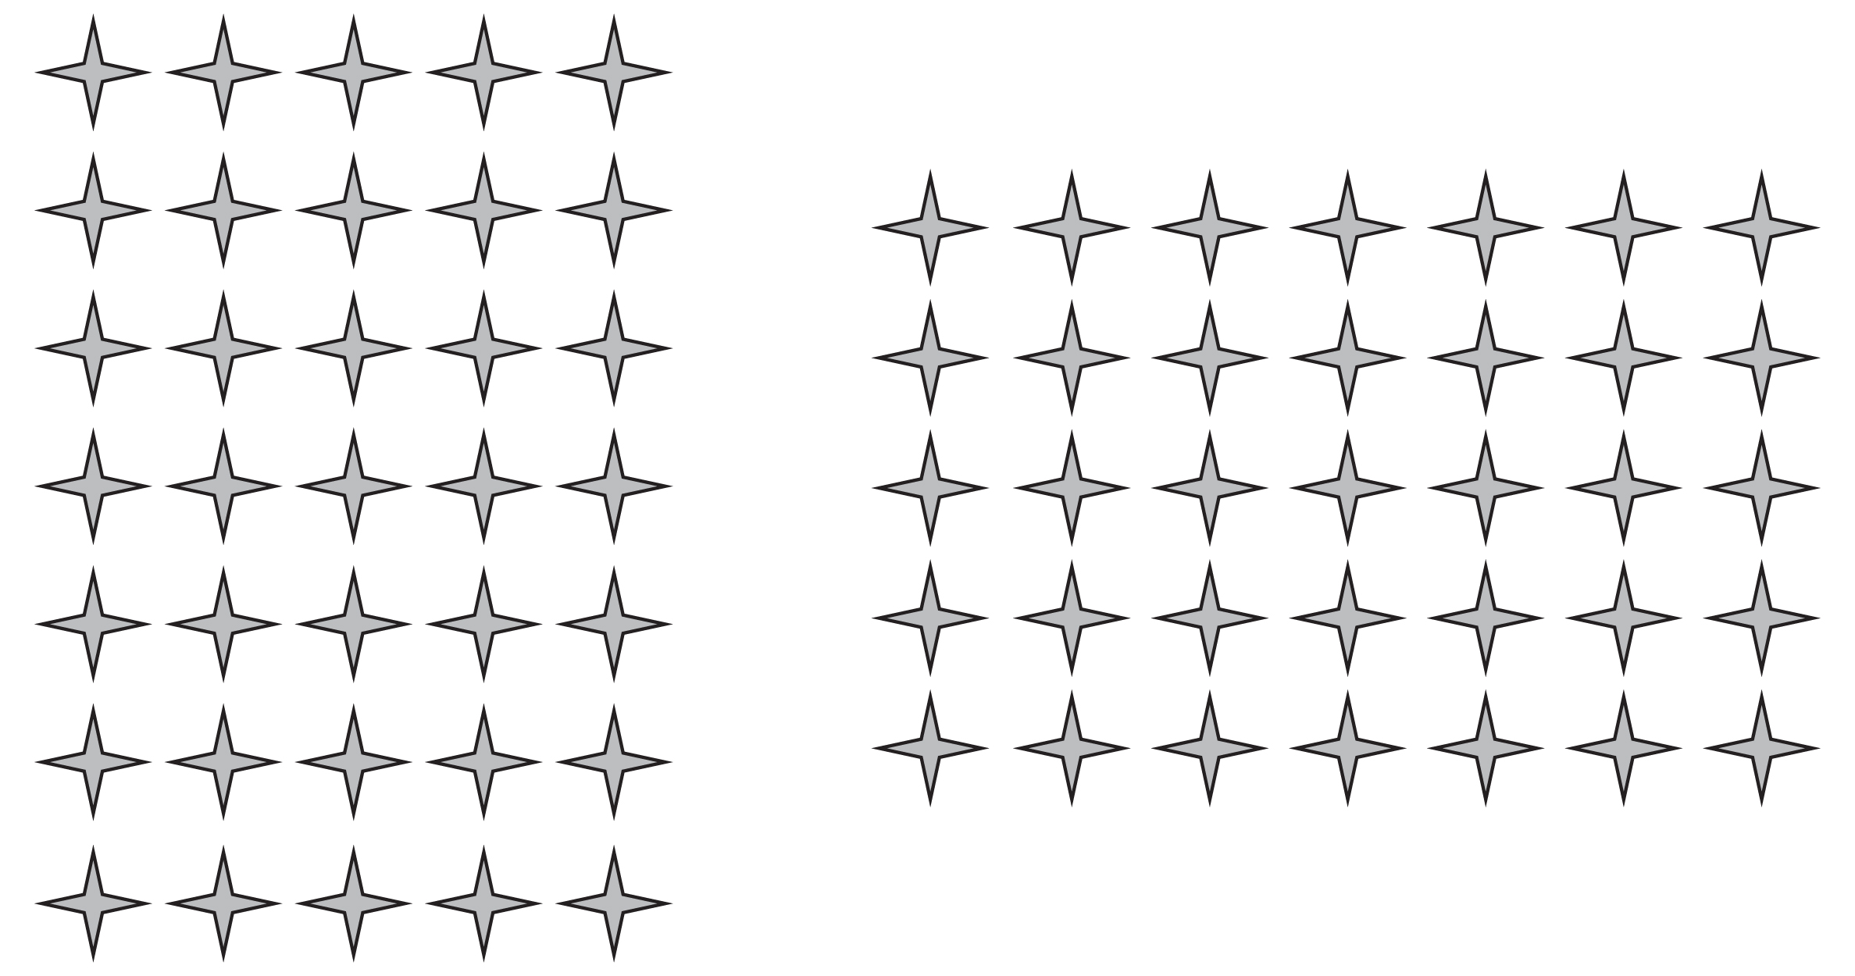

1. Juan drew this number line to model a division problem in his math class. Use the information given with the number line to fill in all of the blanks.

________________ ________________ = ________________

________________ ________________ = ________________

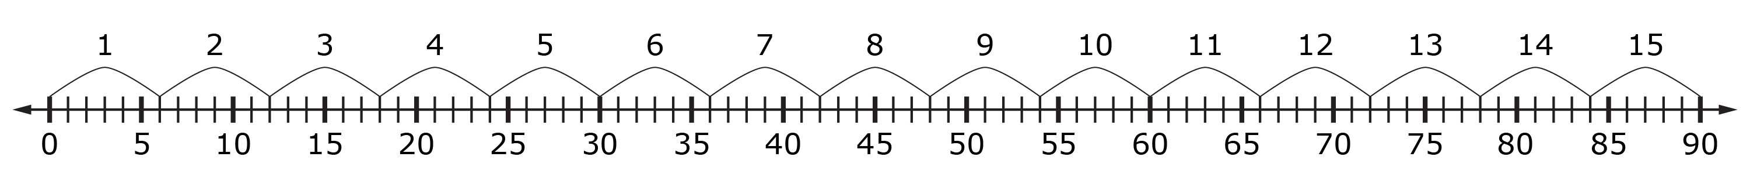

1. Xavier was organizing his sports equipment and decided to store it in different tubs based on the type of sport. He has footballs, soccer balls, lacrosse balls, volleyballs, basketballs, and tennis balls. He has the same number of each type of ball, and a total of 72 balls. How many balls will be placed in each tub?

$÷$________________ ________________ = ________________

­­­­The number ________________ represents:

The number ________________ represents:

The number ________________ represents:



**Array**

1. 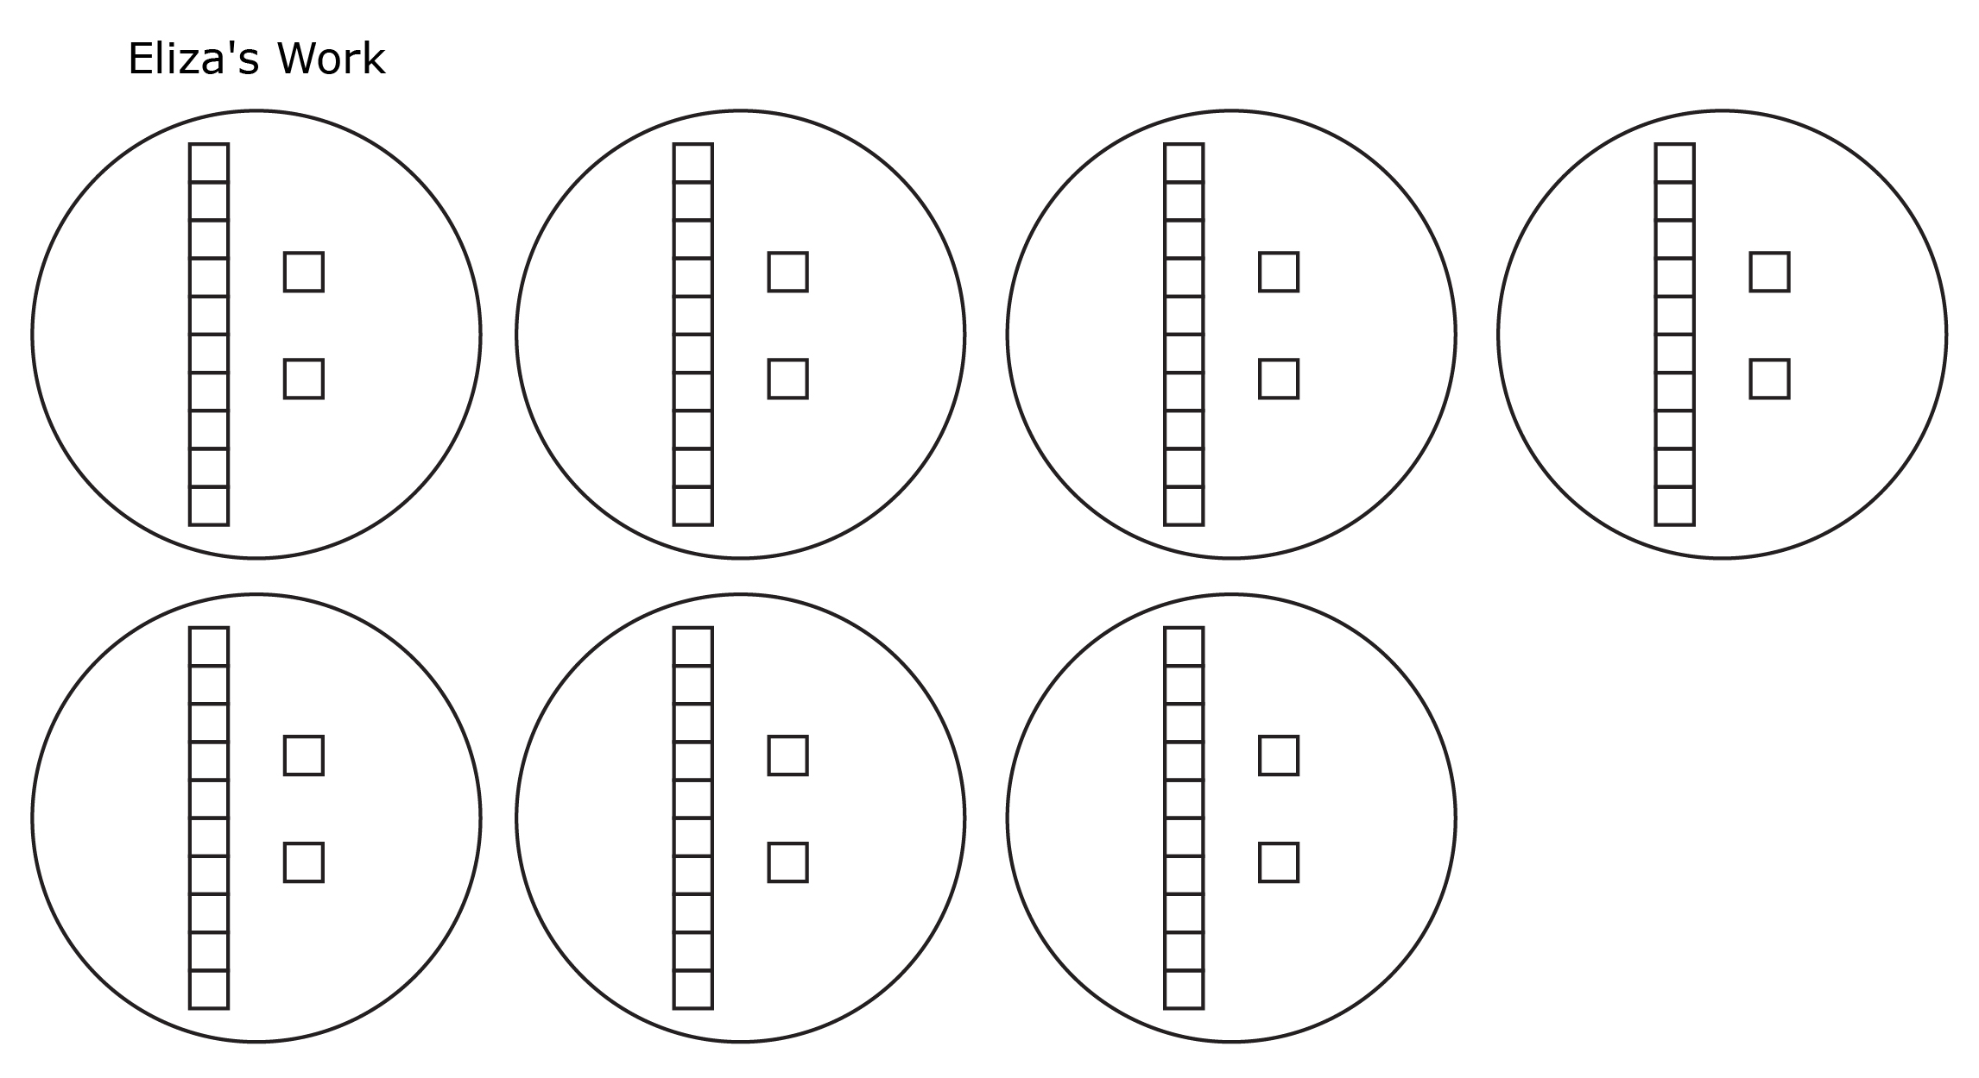Eliza and Zac created the following set models to represent the equation, 84 ÷ 7 = 12. Which answer do you agree with and why?

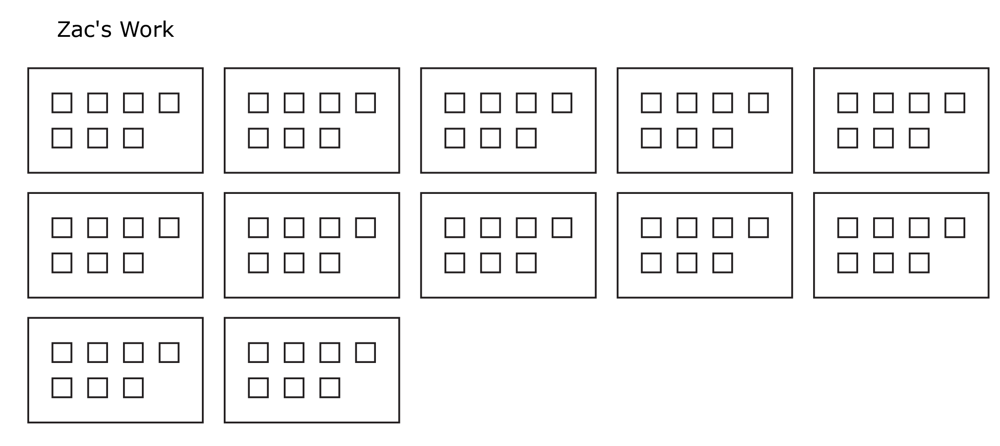

Dividing Whole Numbers

Lesson 2

1. 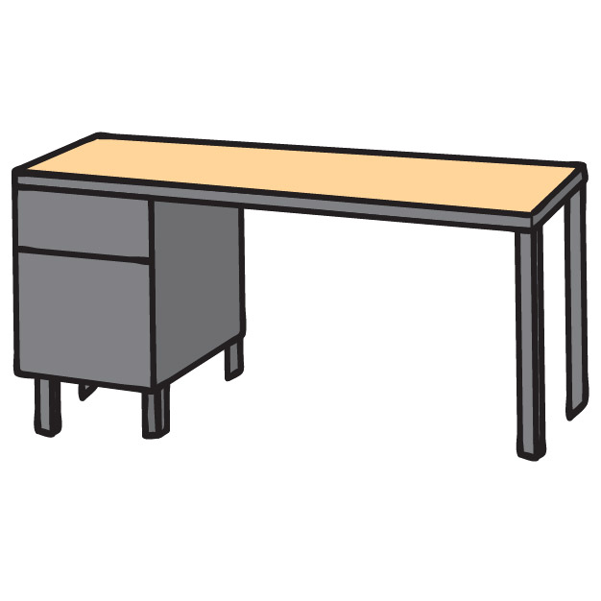In Room 223, every Friday is “Clean Your Desk Day.” Last Friday, Kelli was taking everything out of her desk and making piles of similar supplies. When she was finished, she ended up with nine piles of different supplies. Kelli noticed that all of her piles had the same number of supplies. When she counted all of her supplies, she had a total of 144 pieces to put back into her desk. How many pieces of each supply did Kelli put back into her desk?

Kelli put _______________ pieces of each supply back into her desk.

1. 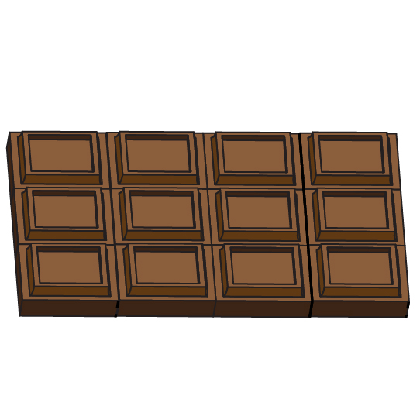Luis is selling candy bars for a school fundraiser. He wants to sell enough to earn the second-place prize, attending a pizza party for lunch. Luis’ goal is to sell 168 candy bars. The candy bars are packaged in boxes of eight. How many boxes of candy bars does Luis have to sell to meet his goal?

Luis has to sell _______________ boxes of candy bars to meet his goal.

1. 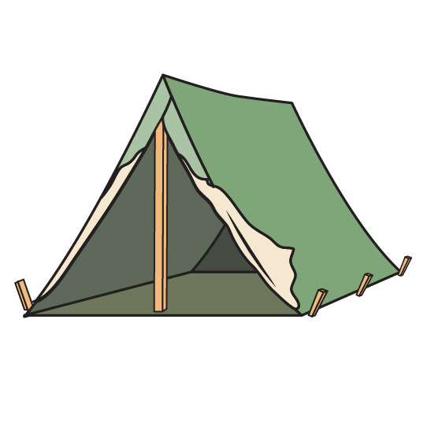Gavin and Sam attended a summer sleepaway camp. There are four camp sessions, each two weeks long. There are 1,184 children signed up to attend a session this summer. If the same number of children are in each session, how many children will be in Gavin and Sam’s session, including them? Be sure to write your answer in a complete sentence.

1. Sarah was given the following problem in her math class.

John is writing a 2,000-word research paper for his science class. He is researching different types of insects in the Amazon rainforest. So far, he has written 1,792 words and has seven sections with subheadings. How many words are in each of John’s sections if all seven sections have the same number of words?

The following is Sarah’s area model. Did she solve the problem correctly? If so, explain how you know. If not, explain what she did wrong and how you know, then provide the correct answer.



Dividing Whole Numbers

INSTRUCTIONAL ACTIVITY SUPPLEMENT

Lesson 2

Division Game Directions

You will need:

* Division Game board (one per group)
* Division Game cards (one set per group)
* Counters or cubes to move around the board (a different color for each student)
* Answer sheet (one per group)
* Dice (one per group)

Directions:

1. Place your counter or cube on “Back to School” (the start space).
2. Stack the game cards face down.
3. Roll the die to decide who goes first (highest or lowest number goes first).

When it is your turn:

1. Roll the die. If you answer your problem correctly, the number you rolled is the number of spaces you will move. If you answer incorrectly, do not move any spaces.
2. Take a card from the top of the stack and show your partner. Both of you solve the problem on your sheet of paper using an area model.
3. After you have both finished solving the quotient, check your answers using the answer sheet.
   1. If you answer correctly, move forward the number of spaces on the board that you rolled with the die. If you answer correctly, your partner does not get to move, even if they answered correctly.
   2. If you answer incorrectly, do not move. If you answer incorrectly and your partner answers correctly, your partner gets to move your number of spaces.
4. Take turns rolling the die.
5. The first person to reach “Summer Break” (the last space) wins the game.

*The small number on the game card matches the number on the answer sheet to make finding the answer easier.

1

____ = 92 $÷$ 4

Answer Sheet

|  |  |  |  |  |  |
| --- | --- | --- | --- | --- | --- |
| 1. | 23 | 17. | 27 | 33. | 56 |
| 2. | 41 | 18. | 73 | 34. | 77 |
| 3. | 14 | 19. | 65 | 35. | 36 |
| 4. | 26 pencils | 20. | 93 | 36. | 3 |
| 5. | 16 | 21. | 83 square feet | 37. | $214 |
| 6. | 33 | 22. | 19 | 38. | 357 |
| 7. | 240, 24, 4; 44 | 23. | 30; 32 | 39. | 960, 16, 1; 61 |
| 8. | 68 | 24. | 19 | 40. | 32 |
| 9. | 51 | 25. | 72 | 41. | 58 |
| 10. | 231 | 26. | 13 | 42. | 13 |
| 11. | 19 pictures | 27. | 85 points | 43. | 17 fifth-grade classes |
| 12. | 16 | 28. | 17 | 44. | 58 |
| 13. | 38 | 29. | 30, 2; 32 | 45. | 495 |
| 14. | 24 | 30. | 6 | 46. | 481 |
| 15. | 82 | 31. | 99 | 47. | 661 |
| 16. | 16 months | 32. | 44 times | 48. | 984 hamburger lunches |

|  |  |  |  |
| --- | --- | --- | --- |
| 1  92 = $×$_____ 4 | 2  328 $÷$ 8 = _____ | 3  _____ = 168 $÷$ 12 | 4  Ms. James bought 130 pencils for her fifth-grade class. She gave each student five pencils to start the year. How many students are in Ms. James’ class? |
| 5  17 $×$_____ = 272 | 6    7 231 | 7  Finish the area model to determine the quotient.  6  40  ?  ?  264  - ? | 8  Two hundred four divided by three |
| 9 $×$ _____ 9 = 459 | 10  4  924 | 11  For her Science Fair project, Mari took 456 pictures for her presentation. She only used $\frac{1}{24}$ of the pictures she took. How many pictures did Mari use on her board? | 12  320 $÷$ 20 = _____ |
| 13  Four hundred ninety-four divided into equal groups of thirteen | 14  144 = 6 $×$_____ | 15  11 902 | 16  Marcus wants to save $864 for a new computer. If he saves $54 a month, how many months will he have to save before he has enough money? |

|  |  |  |  |
| --- | --- | --- | --- |
| 17  594 $÷$ 22 = _____ | 18  657  9 | 19  Seven hundred eighty divided by twelve | 20  8 $×$_____ = 744 |
| 21  Sally was helping her mother make twelve blankets for the school craft fair. They bought 996 square feet of material. How many square feet of material will each blanket need if they are all the same size? | 22    47 893 | 23  Finish the area model to determine the quotient.  46  - 46  0  ?  2  23  736  - 690  46 | 24  114 = $×$_____ 6 |
| 25  Two hundred sixteen divided by three | 26  61  793 | 27  Toby and Ashton were competing for points in their online video game. At the end of the first week, Ashton had eleven times more points than Toby. If Ashton had 935 points, how many did Toby have? | 28  _____ = 731 $÷$ 43 |
| 29  Finish the area model to determine the quotient.  56  - 56  0  ?  ?  28  896  - 840  56 | 30 $×$ _____ 52 = 312 | 31  9 891 | 32  During a science experiment, lab partners needed to record data every twenty-two seconds for 968 seconds during their third-period science class. How many times did the lab partners record data? |

|  |  |  |  |
| --- | --- | --- | --- |
| 33  8 $×$_____ = 448 | 34  11  847 | 35  Nine hundred seventy-two divided by twenty-seven | 36  276 $÷$ 92 = _____ |
| 37  Lucy and her two siblings always received birthday money from their grandparents. If Lucy’s grandparents put aside $642 for birthday money, how much will Lucy and each of her siblings receiving on their birthdays? | 38 $×$   _____ 2 = 714 | 39  Finish the area model to determine the quotient.  ?  60  ?  16  976  - ? | 40  _____ = 992 $÷$ 31 |
| 41  Five hundred twenty-two divided into nine equal groups | 42  75  975 | 43  The school district has five hundred sixty-one fifth-grade math textbooks. Each class receives thirty-three math textbooks. How many fifth-grade classes are in the district? | 44  26 = 1,508 $÷$____ |
| 45  Finish the area model to determine the quotient.  1,485      3 | 46  5,772 $÷$____ = 12 | 47  4 2,644 | 48  The school cafeteria serves 6 French fries with each hamburger lunch. If the cafeteria orders 5,904 French fries, how many hamburger lunches can they serve? |

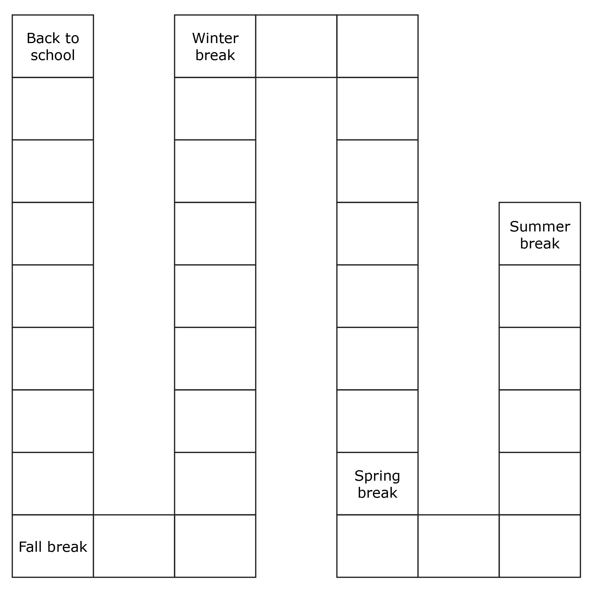

Dividing Whole Numbers

Lesson 3

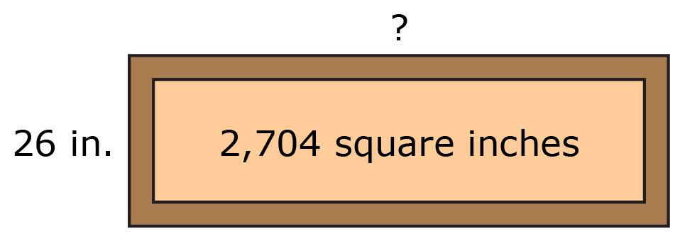1. Brad and Petra were volunteering to clean up a local park. They were in charge of building a sandbox for children to use. The area of the sandbox is 2,704 square inches. If the sandbox is 26 inches wide, how long is the sandbox?

_________________ ÷ _________________ = _________________

_________________ × _________________ = _________________

_________________ ÷ 26

= _________________ + _________________ ÷ 26

= _____________ ÷ _____________ + _____________ ÷ _____________

= _________________ + _________________

= _________________

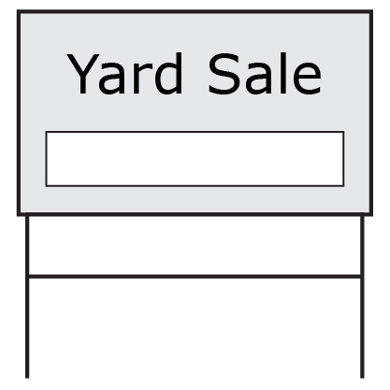2. Franco’s family was having a yard sale. They lived in the middle of a large neighborhood, and Franco wanted to make sure people didn’t get lost on the way to the yard sale. Their house is 1,551 yards from the neighborhood’s south entrance. Franco wanted to place a direction sign every 33 yards. How many signs will Franco need to make?

_________________ ÷ _________________

= (_________________ + _________________) ÷ _________________

= _____________ ÷ _____________ + _____________ ÷ _____________

= _________________ + _________________

= _________________

3. Fill in the blanks.

_________________ × 96 = 2,688

_________________ ÷ _________________

= (_________________ + 768) ÷ _________________

= ______________ ÷ ______________ + 768 ÷ ______________

= 20 + _________________

= _________________

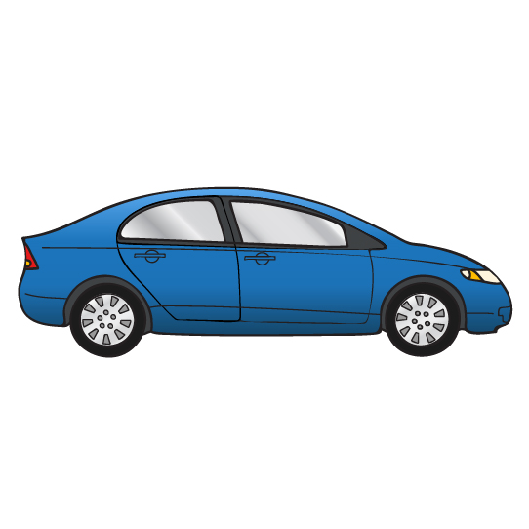4. Ruby is saving her babysitting money to buy a car when she turns 16. So far, she has saved $3,392. If Ruby has been saving for 53 weeks, how much does Ruby earn each week? Show your working using the distributive property.

5. Justin and his friends went to Game Center on Saturday to celebrate his birthday. Justin wanted to earn 1,000 tickets to trade in for a key chain with his favorite video game character. So far Justin has played 18 games and earned 882 tickets. If Justin earned the same number of tickets each game, how many tickets has he earned per game? How many more games does he need to play to earn 1,000 if he earns the same amount of tickets each game? Show your work using the distributive property.



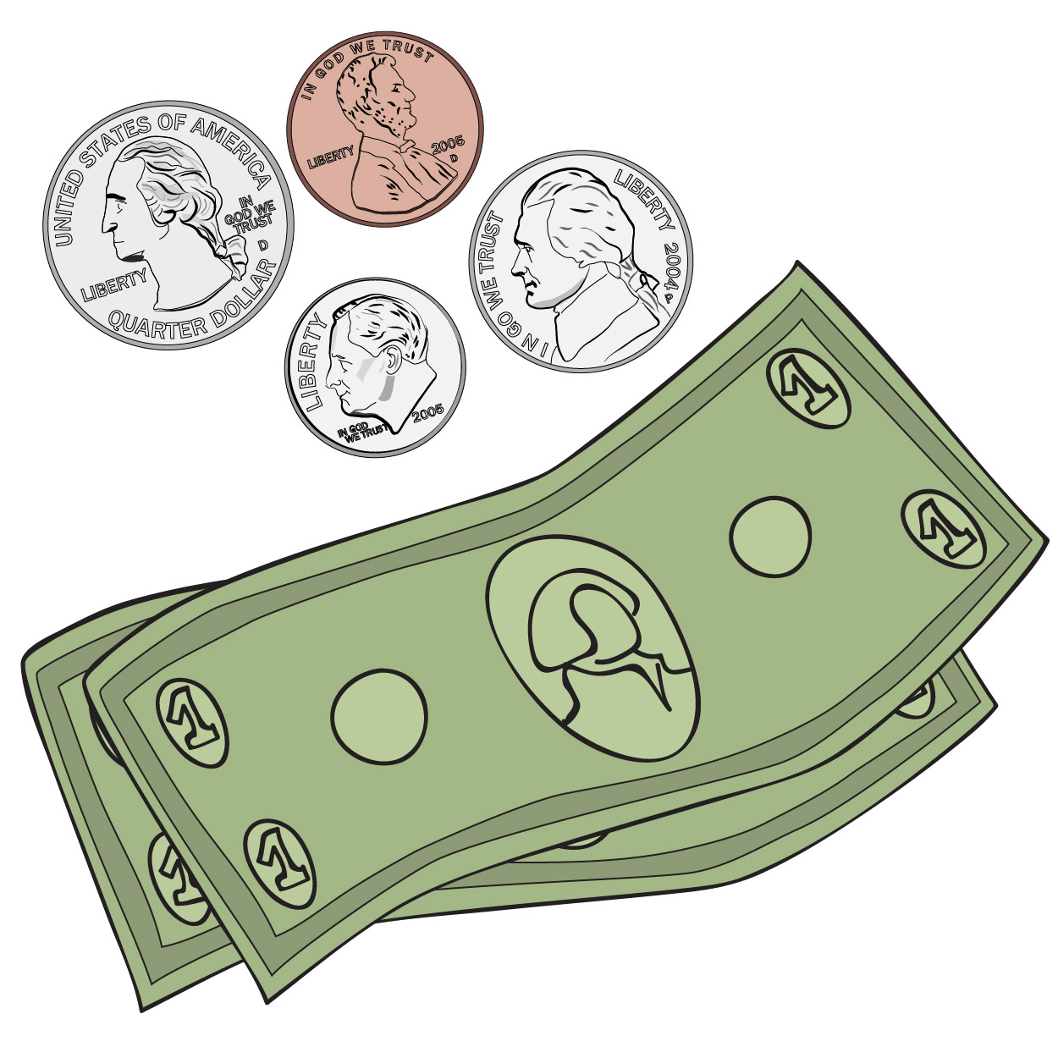6. Review Nicole’s work and solution to the following problem.

Kai has been saving the same amount of money every month for a new computer. Kai has been saving for 12 months. So far, he has saved $648. How much money has Kai saved?

Nicole’s work: *a $×$* 12 = 648

648 ÷ 12 = *a*

*a* = (600 + 48) ÷ 12

*a* = 600 ÷ 12 + 48 ÷ 12

*a* = 5 + 4

*a* = 9

Kai has saved $9 so far.

Is Nicole’s answer correct? If so, how do you know? If not, what was Nicole’s error, and what is the correct answer?

7. Use the distributive property to answer the following questions.

7.a. How many different ways can you decompose 4,475 in order to divide by 5?

7.b. To divide by 5 using the distributive property, could you decompose 4,475 as 500 + 500 + 500 + 500 + 500 + 500 + 500 + 500 + 200 + 200 + 70 + 5? Explain. Would this be an efficient way to decompose 4,475 to divide? Why or why not?

8. Circle the choice that best describes how you feel about dividing whole numbers using the distributive property and the relationship between multiplication and division.

**STOP** – I am totally confused. I do not understand.

**SLOW DOWN** – I think I have got it, but I could use some more practice or clarification.

**GO!** – I’ve got it! I am ready to move on.

Dividing With Whole Number Quotients

Lesson 4

1. A large bag of mini chocolate candies contains 504 individual pieces. Leo wants to split the bag into smaller baggies so he can take some to work each day to share with his coworkers. It took Leo 14 baggies to divide up the large bag of candies equally. How many mini chocolate candies will Leo take to work each day? Show all your work, and write your answer in a complete sentence.

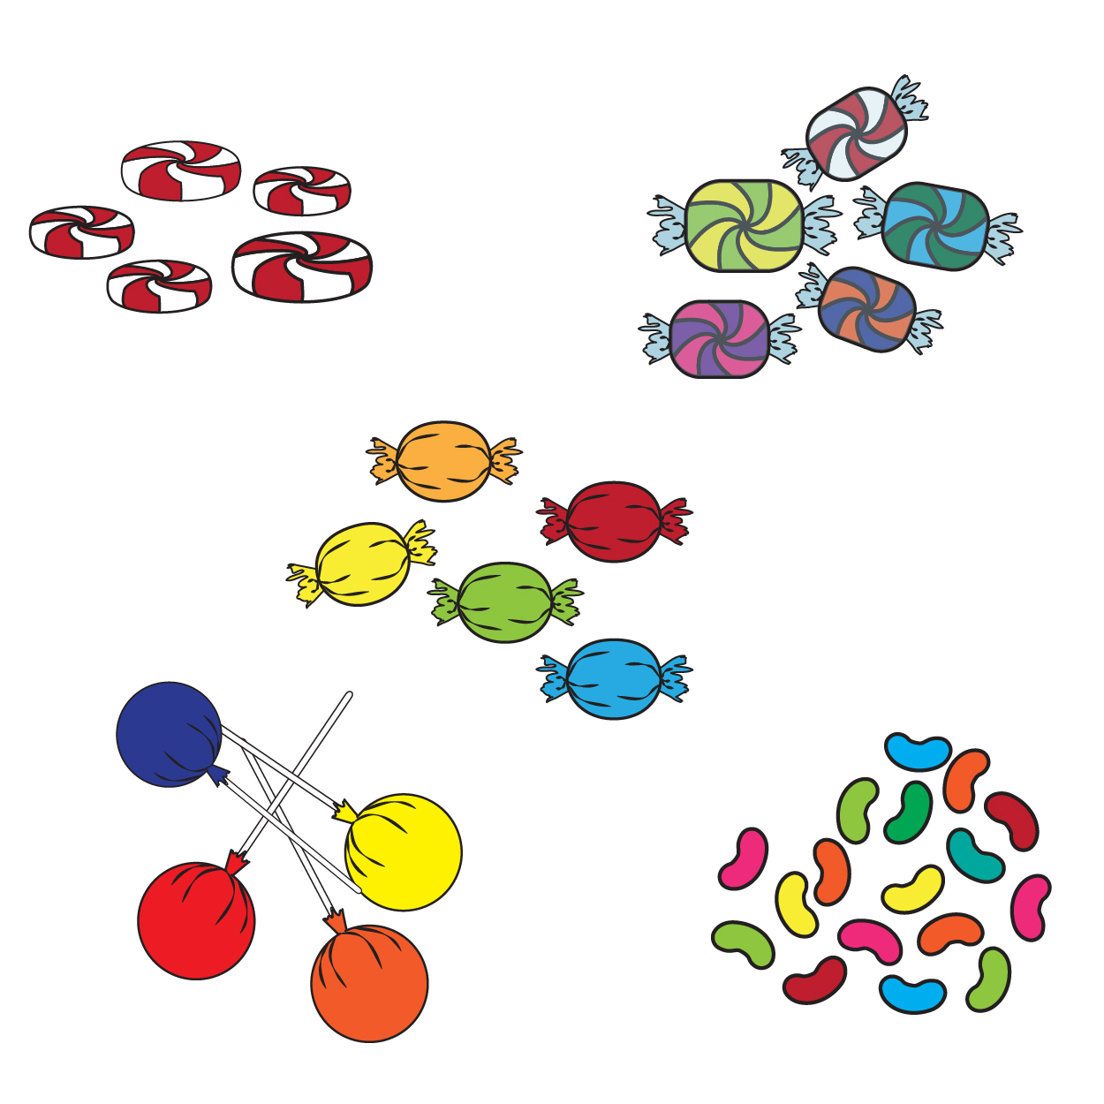

2. Determine the missing value in the equation □ × 27 = 891. Show all your work.

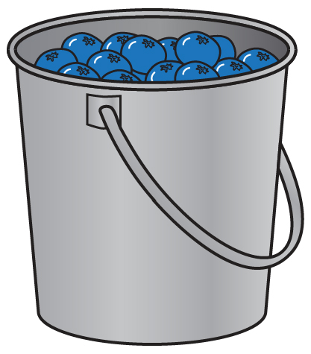3. Abby and her sister spent the day picking blueberries at their aunt and uncle’s farm. They filled up 16 pails total, with the same number of blueberries in each pail. When they returned to the farm house, they cleaned and counted the berries. Together they had picked 1,680 blueberries. How many blueberries were in each pail? Show all your work, and write your answer in a complete sentence.

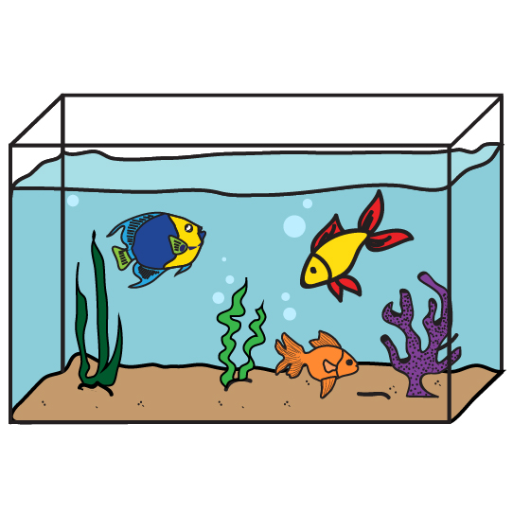4. Bob’s Fish Shop has a large variety of fish available for purchase. Some of the fish are kept in 22-quart tanks. On cleaning day, Bob uses 1,144 quarts of water to refill all the 22-quart tanks. How many 22-quart tanks does Bob need to refill on cleaning day? Show all your work, and write your answer in a complete sentence.

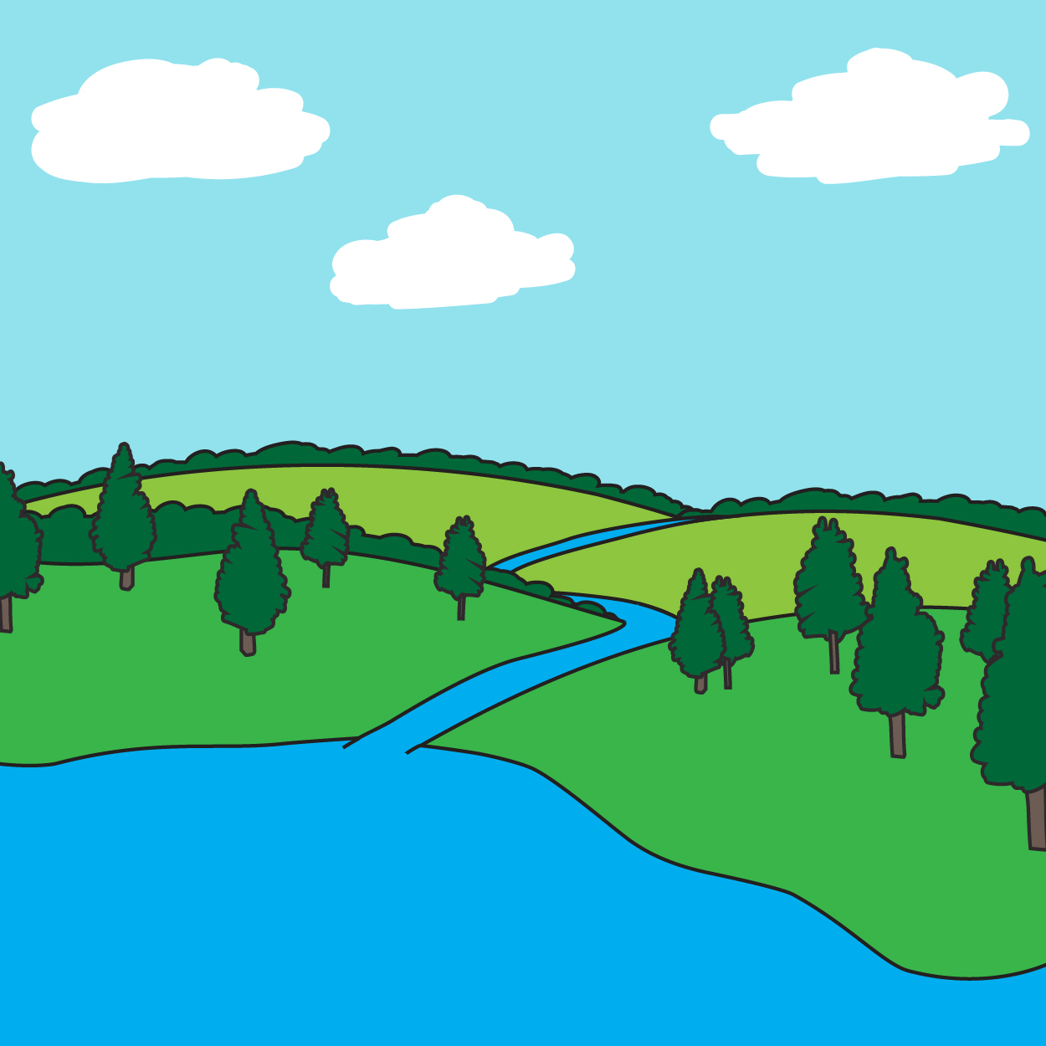5. Four fifth-grade classes went on their weekly walk to the lake to gather plant and water specimens for their science project. There were 42 groups, each with two students. Each group was assigned to bring back the same number of specimens. Once all the classes returned to the school, they went through their collections. Overall there were 672 specimens collected. How many specimens was each group assigned to collect? Show all your work, and write your answer in a complete sentence.

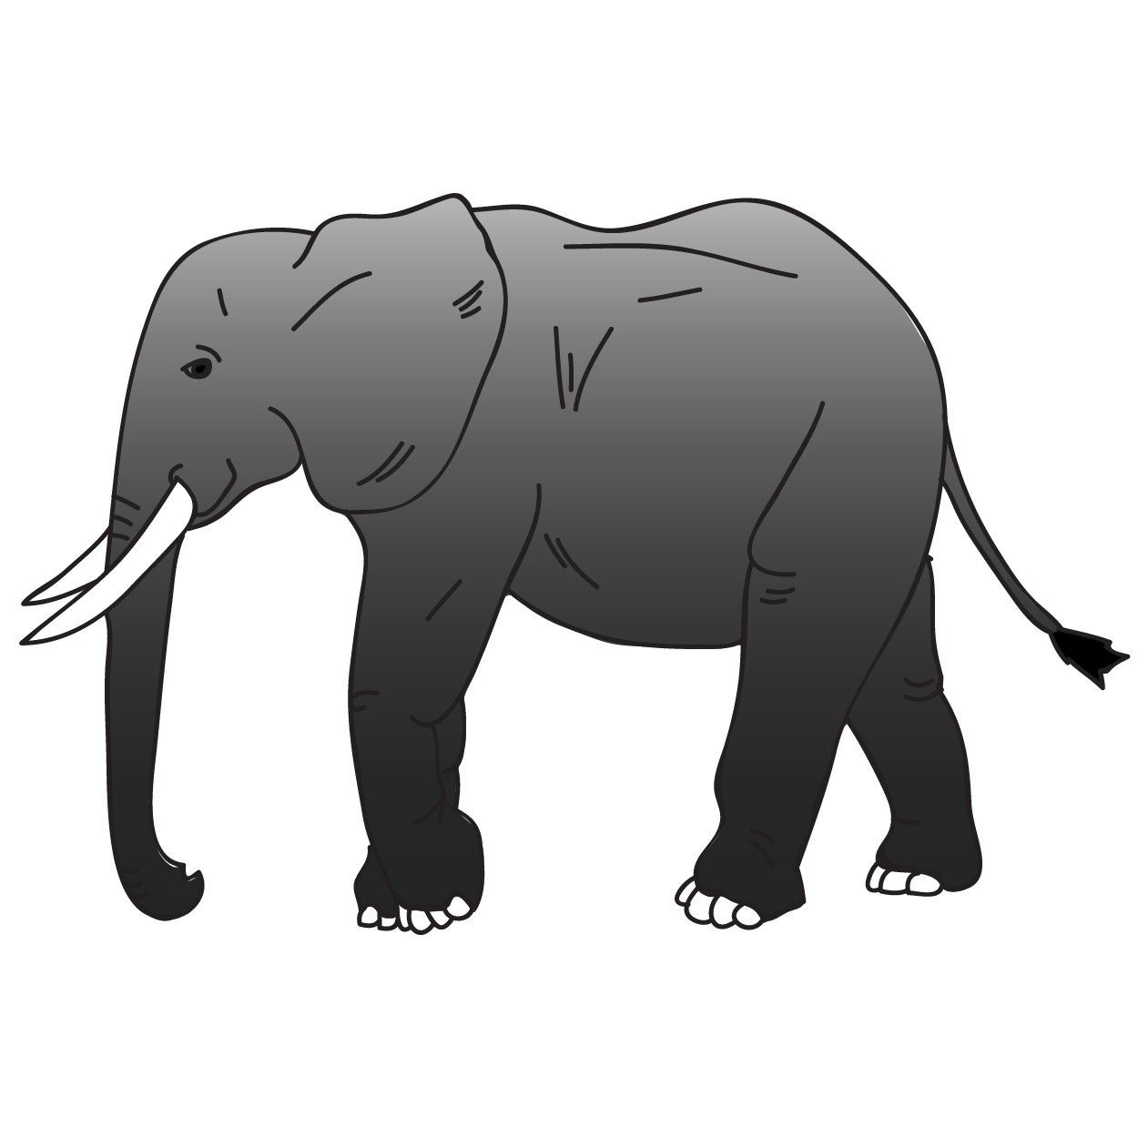6. Evan researched African elephants for his science report. He researched 19 animal reserves in eight different countries in Africa. Combined, the reserves have a total African elephant population of 9,557. If there are the same number of African elephants at each animal reserve, how many elephants live at each reserve?

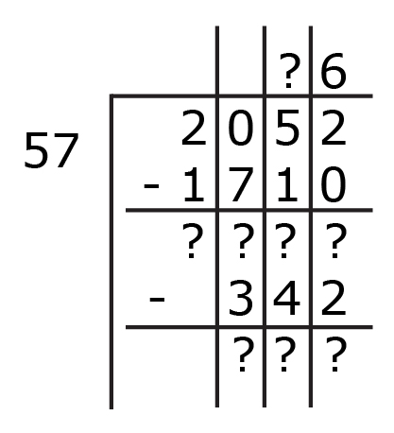7. Complete the division problem by determining the value of each of the question marks. Show all your work.

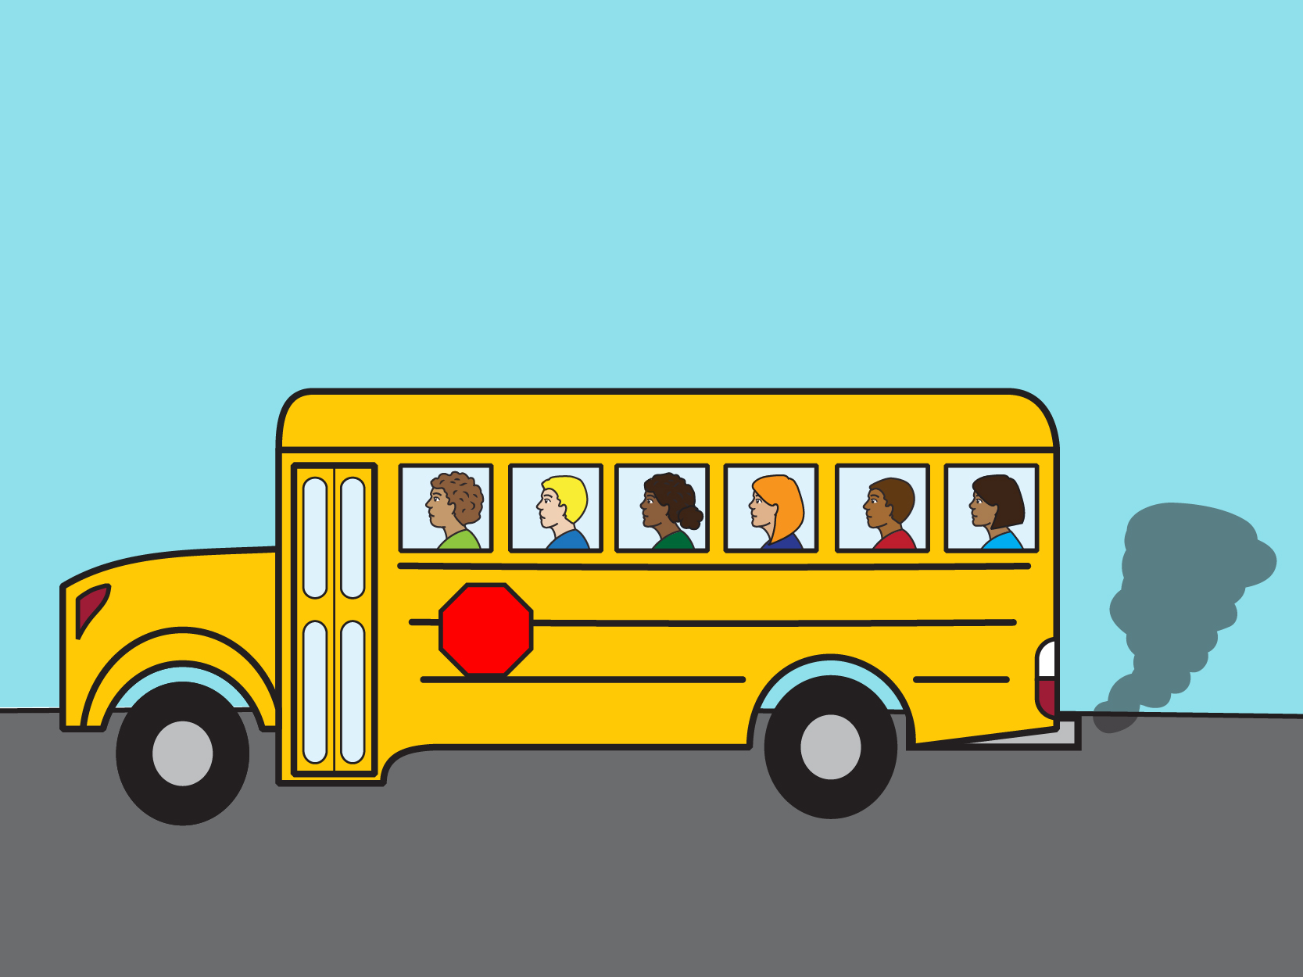8. The fifth-grade advanced history class went on a trip to the state capital to see the state government in session. There were 28 students going on the trip. The total cost for the trip, including the bus and the hotel rooms for two nights, was $2,688. If each student had to pay the same amount, how much did each student need to pay to attend the trip to the state capital? Show all your work, and write your answer in a complete sentence.

9. Determine the missing value in the equation 4,524 = □ × 58. Show all your work.

10. Mr. Henry is getting his classroom ready for the new school year and needs 200 paper clips for different projects. He goes to the office to get paper clips. The office had ordered one large case containing 83 boxes of paper clips. The large case of paper clips contains 7,802 paper clips. How many paper clips are in each box, assuming all boxes have the same number of paper clips? How many boxes of paper clips will Mr. Henry need for his projects? Show all your work, and write your answer in a complete sentence.

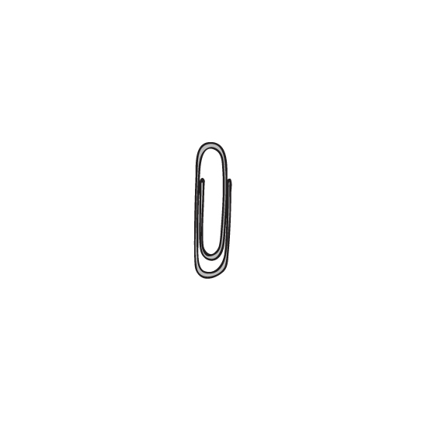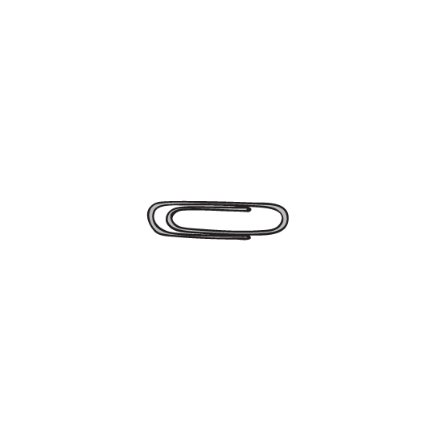

Dividing Whole Numbers

Lessons 1 – 4

1. During the school year, Janie has a TV time limit of 8 hours each week. She is limited to 288 hours of TV time for the school year. How many weeks are in the school year? Create an array in the space provided to show your work.

___________ hours total

___________ hours per week

­­­­___________ weeks

$×$ ­­­­___________ ___________ =

$÷$ ___________

___________ ___________ = ___________

**Array**

1. Bella had her birthday party at a local park. The picnic tables were hidden in the park, so Bella marked the path from the parking lot to the tables with balloons. Bella placed one balloon every nine yards. The total distance on the path from the parking lot to the tables was 162 yards. How many balloons did Bella need to mark the entire path? Be sure to label and use the number line to show your work.

**Number Line**

___________ distance from parking lot to picnic tables

___________ distance between each balloon

­­­­___________ number of balloons

$×$ ­­­­___________ ___________ =

$÷$ ___________

___________ ___________ = ___________

1. Use the set group model with base-ten blocks to fill in the blanks.

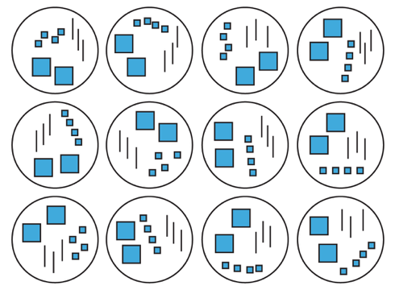

___________ number of groups

___________ number in each group

­­­­___________ total

$×$ ­­­­__________ __________ =

$÷$ __________

__________ __________ = __________

1. For his snack day at school, Marco wants to bring carrots and ranch dressing. Marco’s mom purchases one bag of baby carrots that contains 200 carrots. Marco determines that he needs 184 carrots for his class. There are 23 students in his class, including Marco. How many baby carrots will each student receive? Create an array in the space provided to show your work.

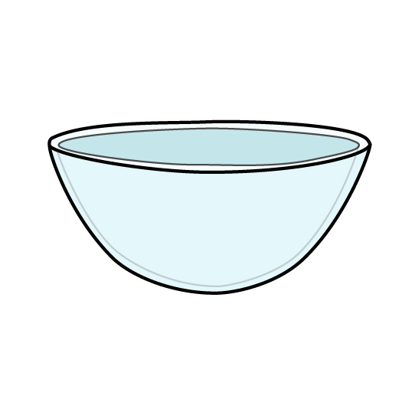

**Array**

$÷$___________ ___________ = ___________

­­­­The number ___________ represents:

The number ___________ represents:

The number ___________ represents:

1. Solve the following problems using an area model.
   1. Mr. Smith plays music for his students while they are working. His music website tracks his listening time. On Monday he checked how much time his class listened to music during five school days in the previous week. The total listening time was 1,200 minutes. How many minutes did Mr. Smith’s class listen to music each day last week if they listened to music for the same amount of time each day? Show all your work, and answer in a complete sentence.

* 1. ­­ ___________ 9 = 5,067

* 1. Fill in the blanks to complete the area model.

4

1 3 6 8

– _____________

_______________

______________

– 1 6 0 8

______________

8

– 8

0

2

* 1. ___________ = 6,816 12

1. Solve the following problems using the distributive property.
   1. Fill in the blanks.

$×$_______________ 24 = 6,192

$÷$

_______________ _______________

= (2,400 $+$ $+$ $+$____________ ____________ 192) $÷$

____________

= 2,400 $÷$ 24 $+$ $÷$ $+$ $÷$

$+$____________ ____________ ____________

____________ 192 $÷$ 24

= 100 _______________ _______________ 8

= _______________

* 1. The pool needs a new rectangular cover for when the pool is closed. The area of the pool cover the manager ordered is 3,234 square feet. The width of the pool cover is 21 feet. How long is the pool cover? Will the pool cover fit a rectangular pool that is 150 feet long? Show all your work, and answer in a complete sentence.

* 1. Every Saturday, Marcie’s aunt takes her to Game Center. Marcie loves to play the games that award tickets because she is saving for a large stuffed dog. So far Marcie has saved 2,280 tickets over six weeks. How many tickets does Marcie earn each Saturday if she earns the same number of tickets each week? Show all your work, and answer in a complete sentence.



1. Solve the following problems using the standard algorithm, with or without partial quotients.
   1. Jasmine and her family are driving to California for summer vacation. The drive from her home in Ohio to the beach house is 2,624 miles. Every 82 miles, Jasmine asks if they are there yet. How many times does Jasmine ask her parents if they are there yet? Show all your work, and answer in a complete sentence.

2624

82

* 1. 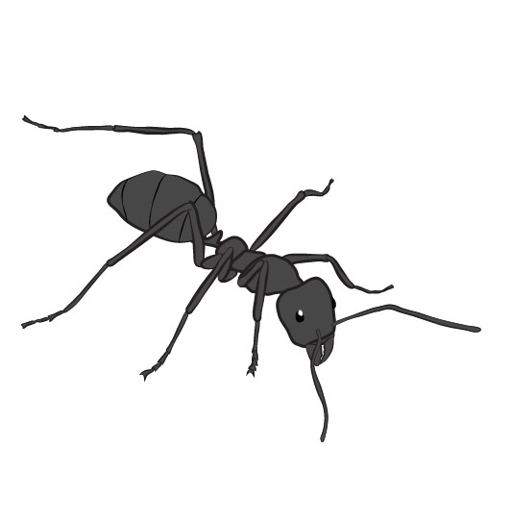Maria read about an ant colony in Europe that covers 3,828 miles underground and is made up of 33 different nests. How many miles does each nest cover if the nests are equally spaced? Show all your work, and answer in a complete sentence.

3 8 2 8

33

* 1. 58 ___________ = 4,350

* 1. Simone’s work for the expression 4,727 $÷$ 29 is shown in the following picture. Is Simone’s work correct? If so, how do you know? If not, identify her mistake, and provide the correct quotient.

